Exam Form System Web Application

1. Student Exam

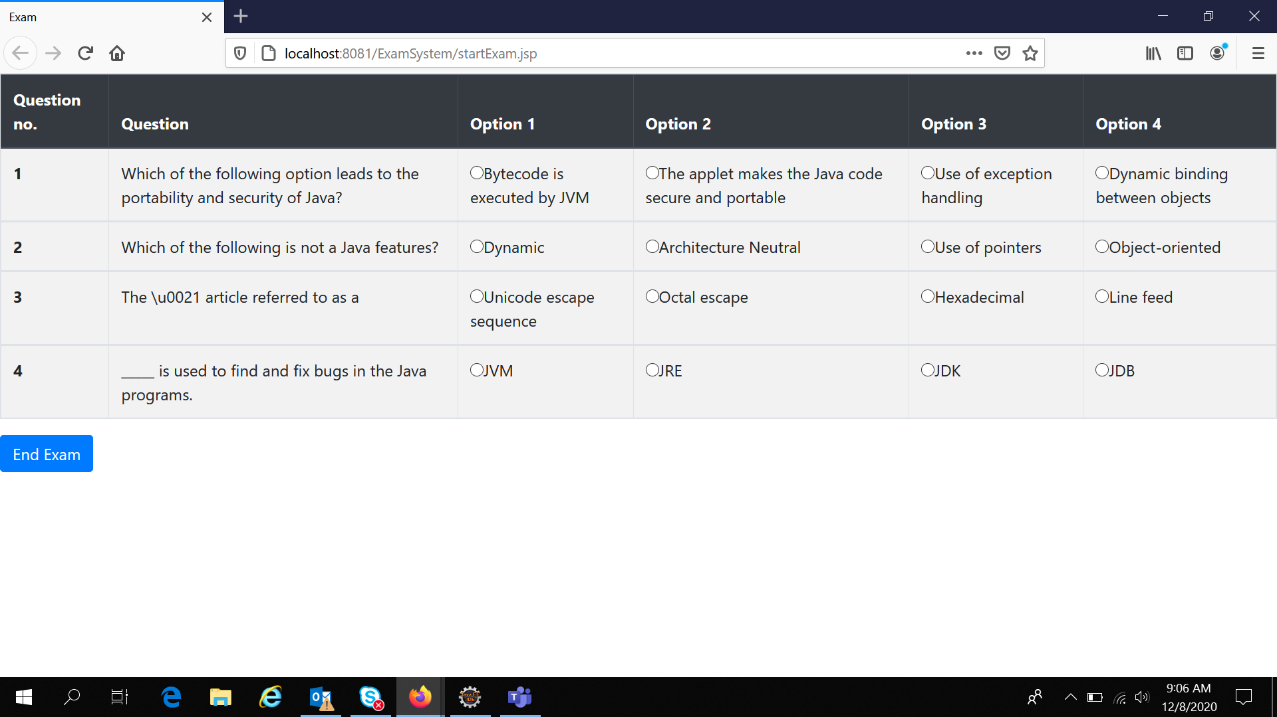

1. View Scores (Student)

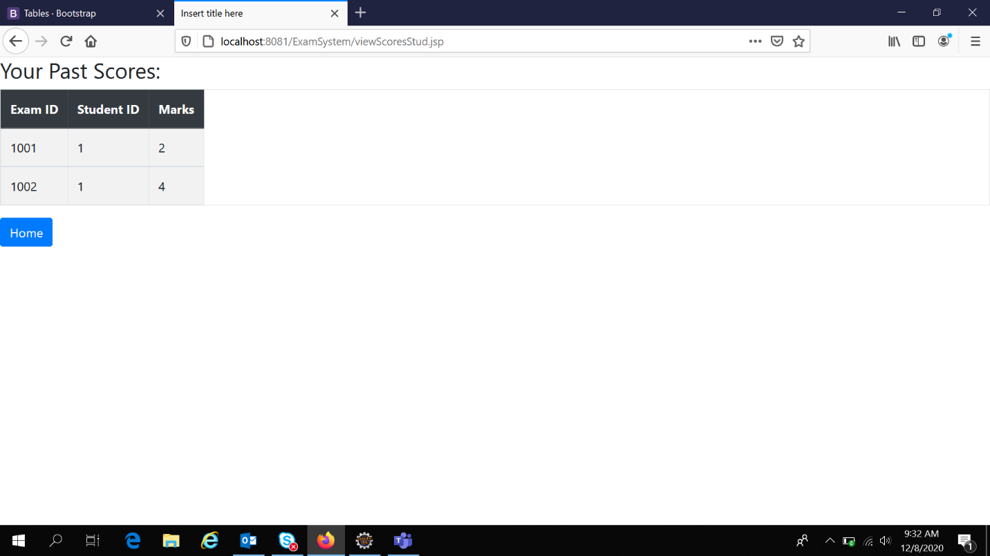

1. Add New Question (Teacher)

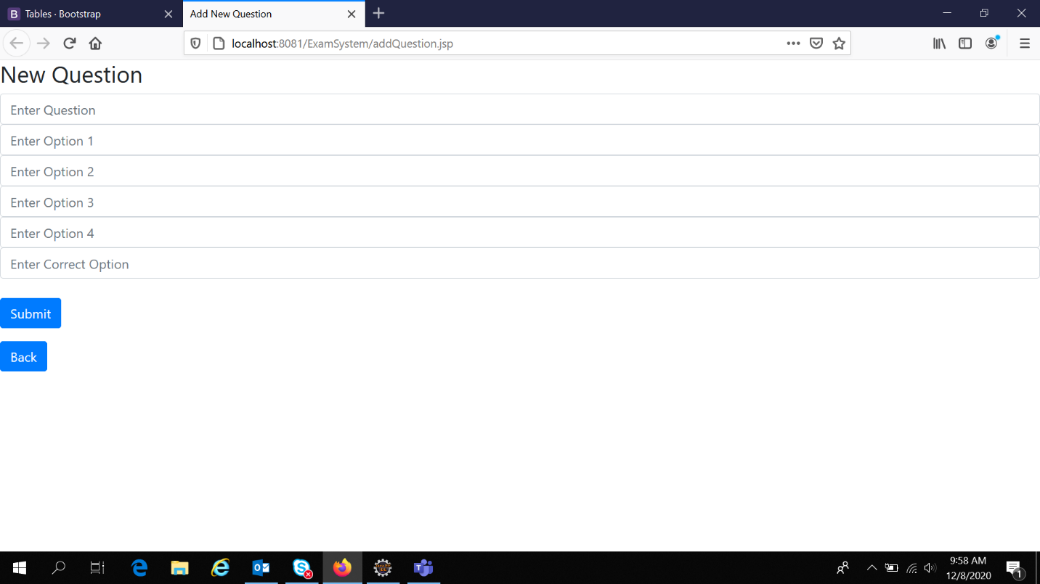

1. View All Students’ Scores (Teacher)

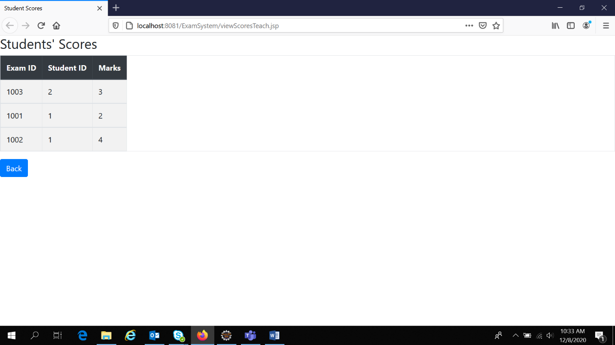

**Important Files:**

1. StudentLogin.java and TeacherLogin.java – Respective Login Servlets with credential checking
2. AddQuestion.java – Servlet for teacher functionality for adding new question
3. studProfile.jsp and teacherProfile.jsp – Respective Profile pages on Login
4. startExam.jsp – Invoked when student starts exam. Displays questions for the student.
5. showResult.jsp – Displays result of the student
6. viewScores Stud/Teach – Respective pages to view scores of current student and of all students (for teacher)